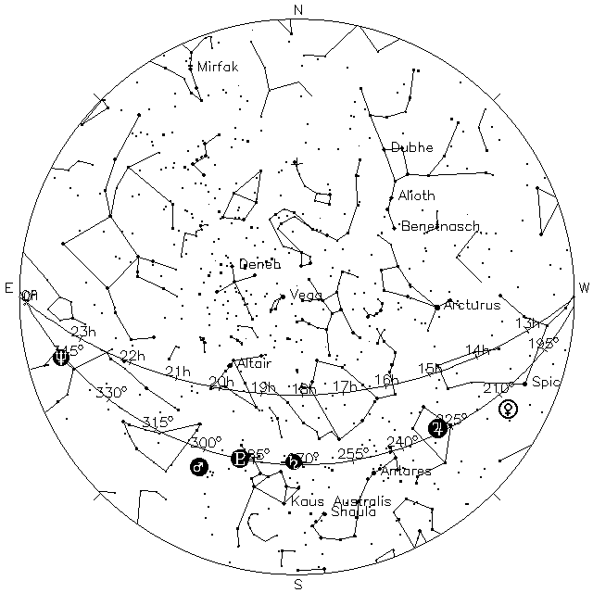
Sky as seen at Washington DC 2018-09-09 20:00 EDT = 2018-09-10 00:00 UT = JD 2458371.5
AHSP2018 ~8 P.M.

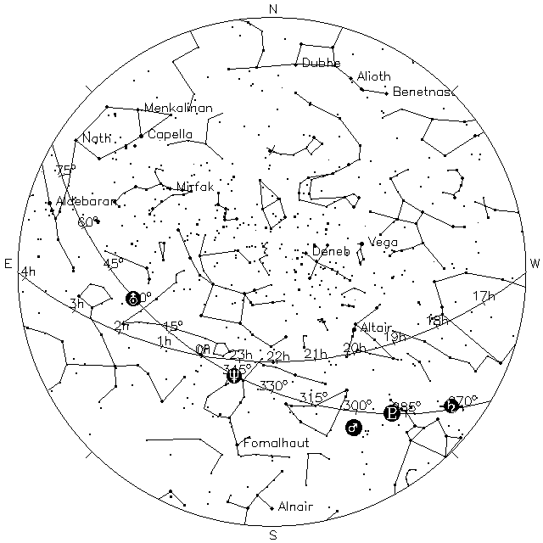
Sky as seen at Washington DC 2018-09-10 00:00 EDT = 2018-09-10 04:00 UT
AHSP2018 ~Midnight

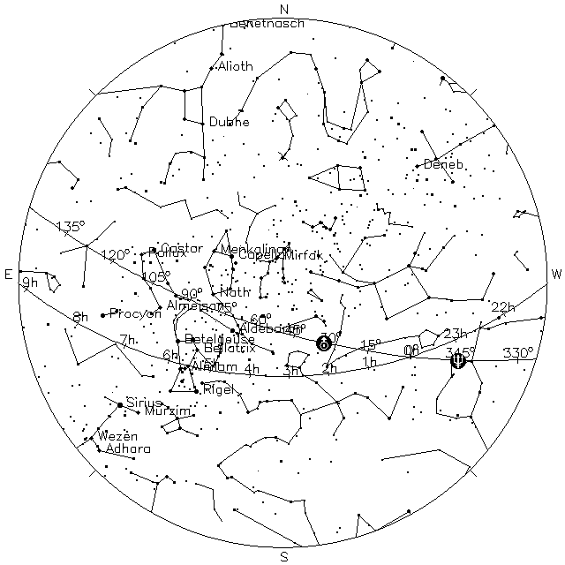
Sky as seen at Washington DC 2018-09-10 05:00 EDT = 2018-09-10 09:00 UT
AHSP2018 ~5 A.M.

